**EXPERIMENT-2**

Name: K.Sriya

Roll No: 2320090043

**AIM:** Execute the following networking commands like **ipconfig, tracert, telnet, netsh, ping, nslookup and netstat** in the command prompt with simple topology.

**Apparatus Required:** Router, Switch, PC, Server, Copper straight-through cable.

# Procedure:

**Step 1:** Open Cisco Packet Tracer.

**Step 2:** Create a simple network topology:

* Add one Router
* Two switches
* Two PCs

**Step 3:** Connect the devices:

* Give IP addresses to the PCs:
  + PC1: 192.168.1.2
  + PC2: 192.168.2.7
* Give Default Gateway:
  + PC1: 192.168.1.1
  + PC2: 192.168.2.1
* Assign IP addresses to the router:
  + G0/0: IP address 192.168.1.1
  + G0/1: IP address 192.168.2.1

**Step 4:** Connect PCs to Switch with copper straight-through cable.

**Step 5:** Connect switch to the router using cable and router to switch using cable.

1. Open command prompt on PC and ping PC's IP address.
2. Using ipconfig command which displays all current TCP/IP network configuration values and refreshes DHCP & DNS settings.
3. Use tracert command to trace the path taken to a destination by sending ICMP echo request messages.
4. Using telnet command is used for interactive communication with another host using the Telnet protocol.
5. In the router, go to config tab and select the interface connected to the switch (e.g., G0/0) and assign IP address. Give some commands.

**Step 6:** Add server to the switch.

**Step 7:** Using nslookup command to check if the DNS server configuration is correctly configured and running.

**DNS Entries:** The DNS entry for [www.google.com](http://www.google.com/) should be added to the DNS server with an IP address.

**Result:** Using the commands ipconfig, tracert, telnet, ping, and nslookup, I have observed a simple network.

# ipconfig command:

C:\>ipconfig

FastEthernet0 connection: (default port) Connection-specific DNS suffix:

Link-local IPv6 Address: FE80::201:6FF:FEBA:C266 IPv4 Address: 192.168.1.2

Subnet Mask: 255.255.255.0

Default Gateway: 192.168.1.1

Bluetooth connection:

Connection-specific DNS suffix:

Link-local IPv6 Address:

IPv6 Address:

IPv4 Address:

Subnet Mask: 0.0.0.0

Default Gateway: 0.0.0.0

# tracert command:

C:\>tracert 192.168.2.2

Tracing route to 192.168.2.2 over a maximum of 30 hops:

1 <1 ms> <1 ms> 192.168.1.1

2 * <1 ms> 192.168.2.2

# Configure the route:

Router>enable

Router#configure terminal Router(config)#line vty 0 4 Router(config-line)#password cisco Router(config-line)#login Router(config-line)#exit Router(config)#end

Router#write memory

# Telnet:

Router>telnet 192.168.1.1 23

Trying 192.168.1.1 ... open User Access Verification Password:

Router>

**Route configuration and Brief IP interface. Ping 192.168.2.2:**

**C:\>nslookup** [**www.google.com**](http://www.google.com/) **Server: 255.255.255.255**

**Address: 255.255.255.255**

Non-authoritative answer:

**Name:** [**www.google.com**](http://www.google.com/) **Address: 8.8.8.8**

**Configure the router:**

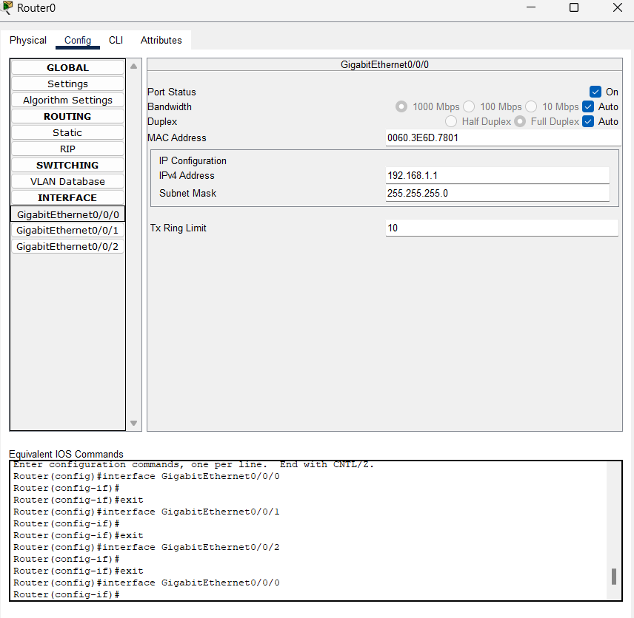Interface G0/0: IP address 192.168.1.1, Subnet Mask 255.255.255.0

Interface G0/1: IP address 192.168.2.1, Subnet Mask 255.255.255.0

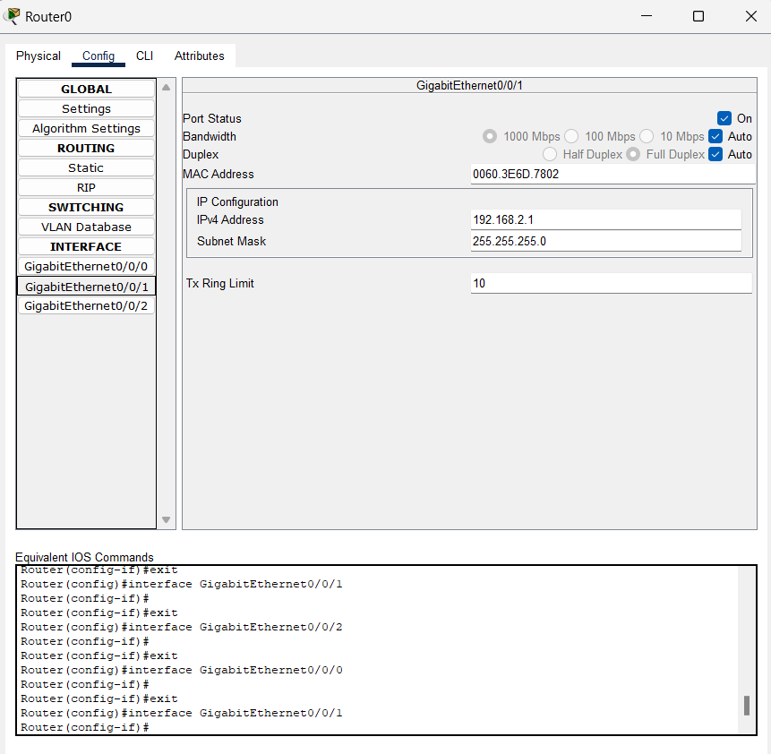

**Configure the PCs:**

PC0: IP address 192.168.1.2, Subnet Mask 255.255.255.0, Default Gateway 192.168.1.1

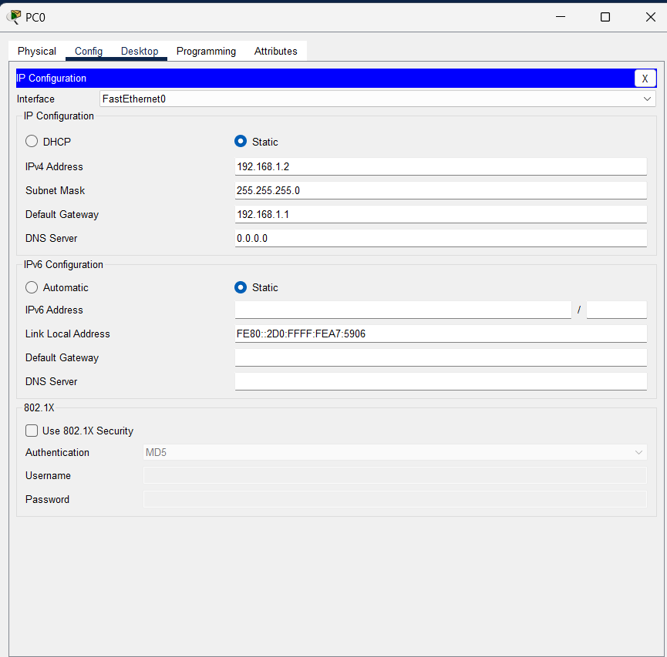

PC1: IP address 192.168.2.2, Subnet Mask 255.255.255.0, Default Gateway 192.168.2.1

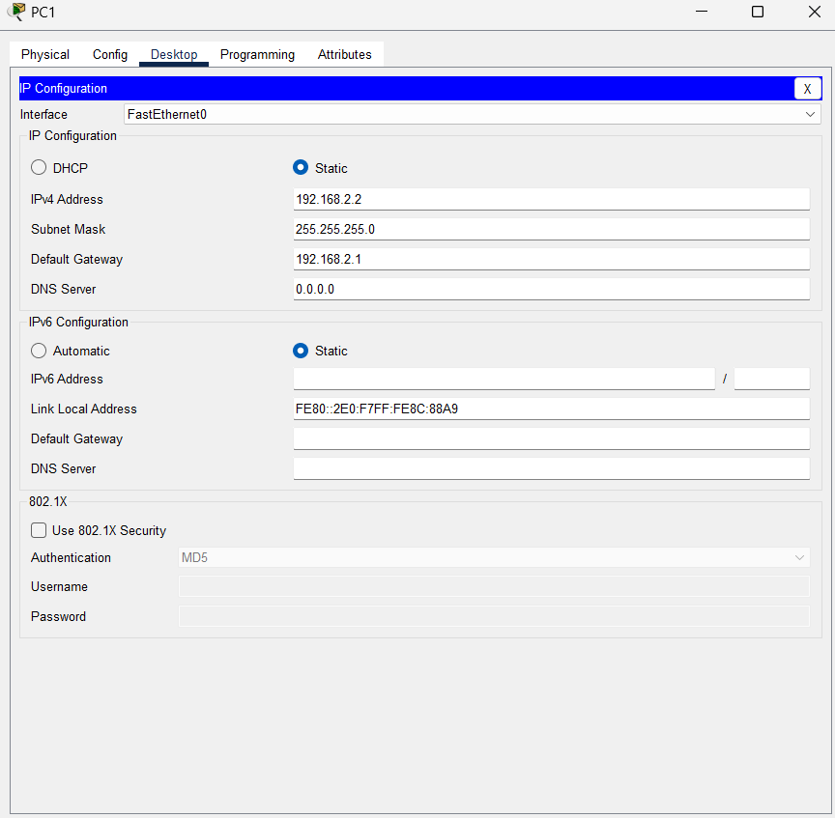

**Execute Networking Commands**

* **ipconfig**:

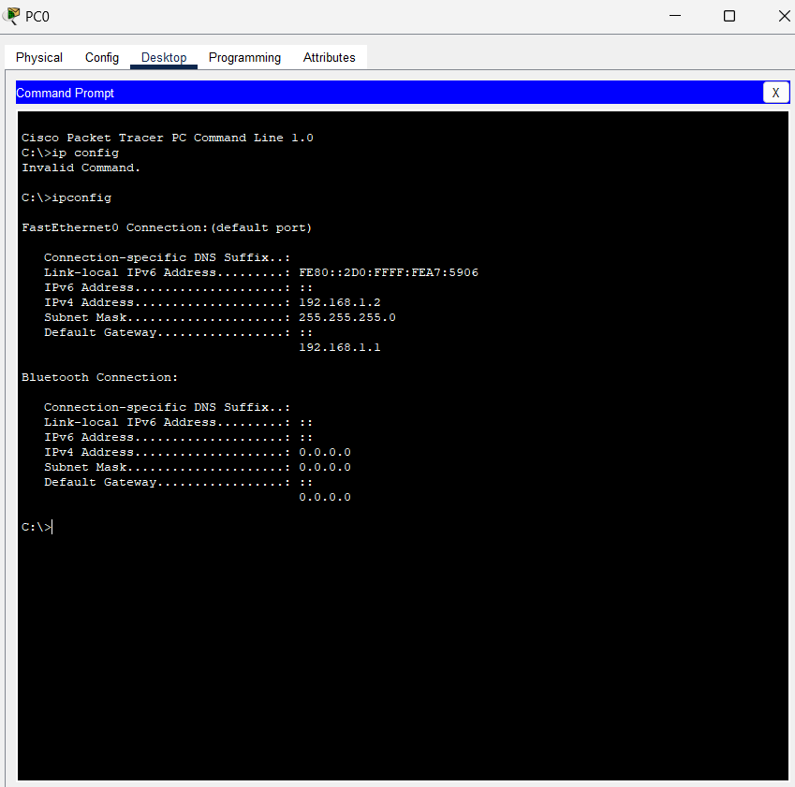

* **tracert**:

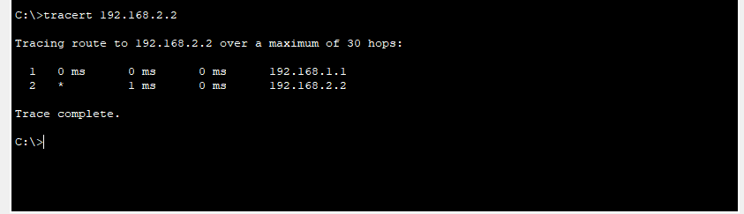

**Configure the Router**

* **Assign IP Address:**

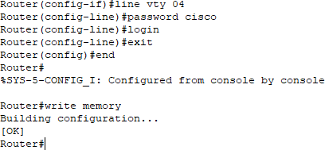

* **Telnet**

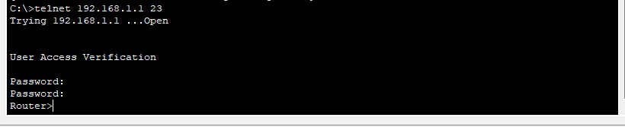

* **Router configuration and Brief Ip Interface**

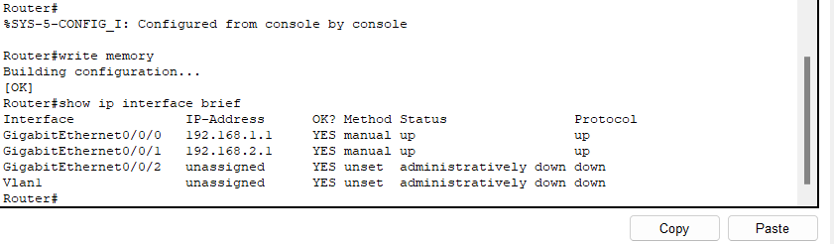

* **Ping 192.168.2.2**

**ICMP Echo**

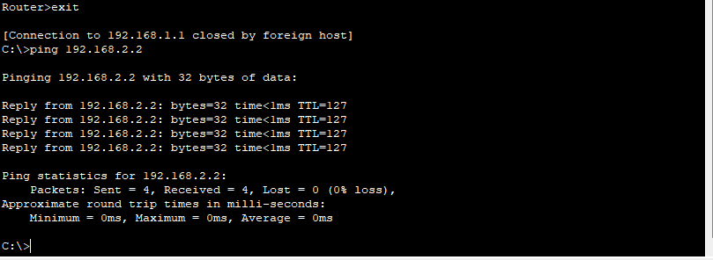

* 1. **Add one server (to act as a DNS server).**
  2. **Connect both PCs and the server to the switch using copper straight-through cables.**

**Configure the DNS server**

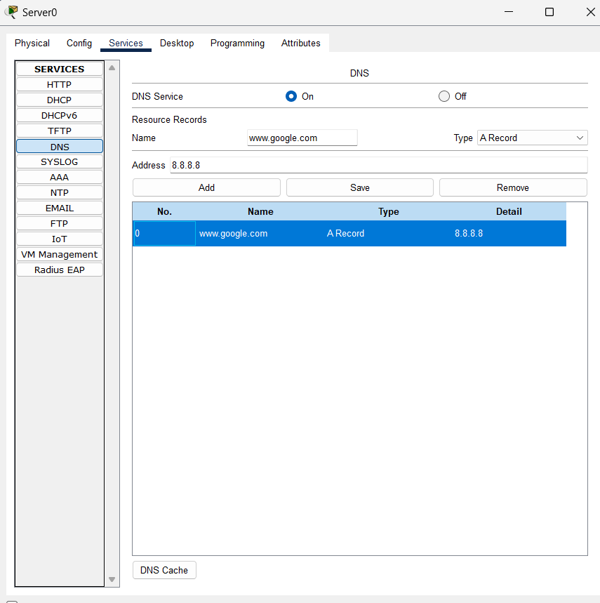

* **use nslookup command**

